Monolithic Architecture:
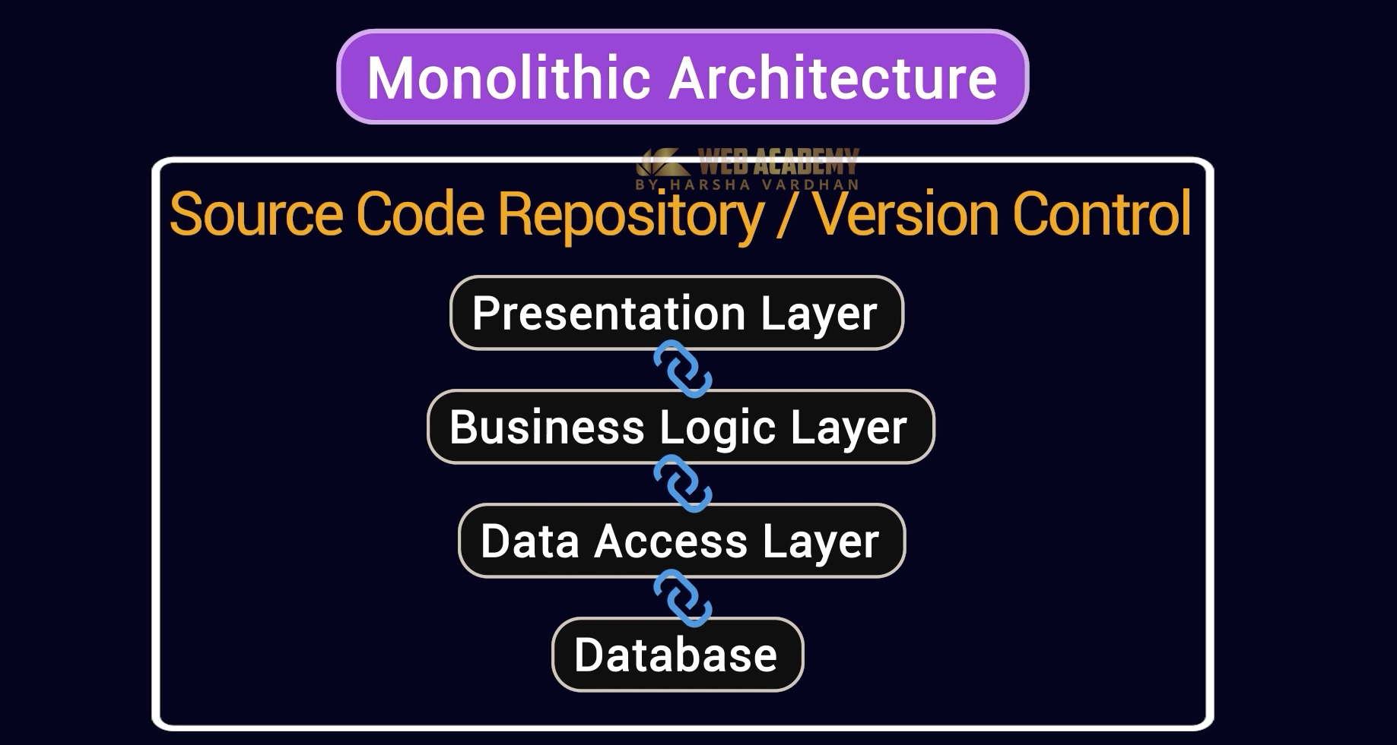
Draw Backs:
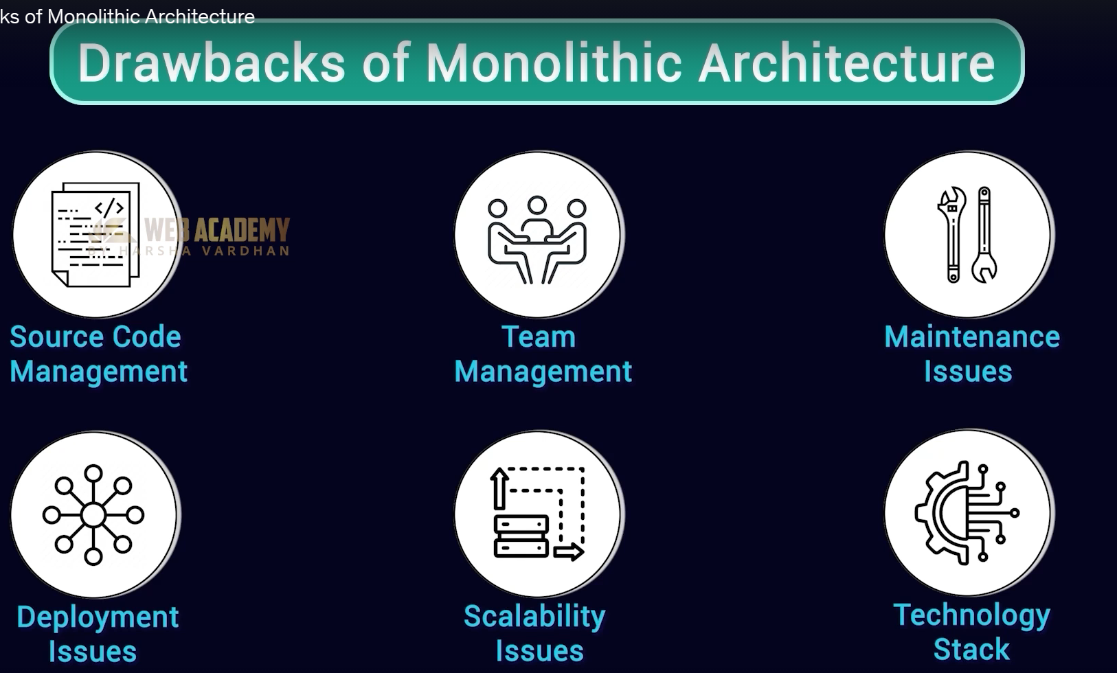
Tech Stack: All the components should be written in a single language
Scalability: Let’s we have 3 componets one of it have high demand. To scale up the hard ware for that particular component. We have scale up the whole system.
Principles of MicroServices:
- Agility: Adding new features
- Decomposition: Different components instead of one application
- Autonomy: Different language can be used for components
- Independence: Don’t dependent upon another components
- Api based comm: Get data from other service through restful endpoint
- Scalability: Can scale only one componet
- Resilence : Handling one component response when other other component fails which needs data.
- Testing: Can test only one component instead of whole app.
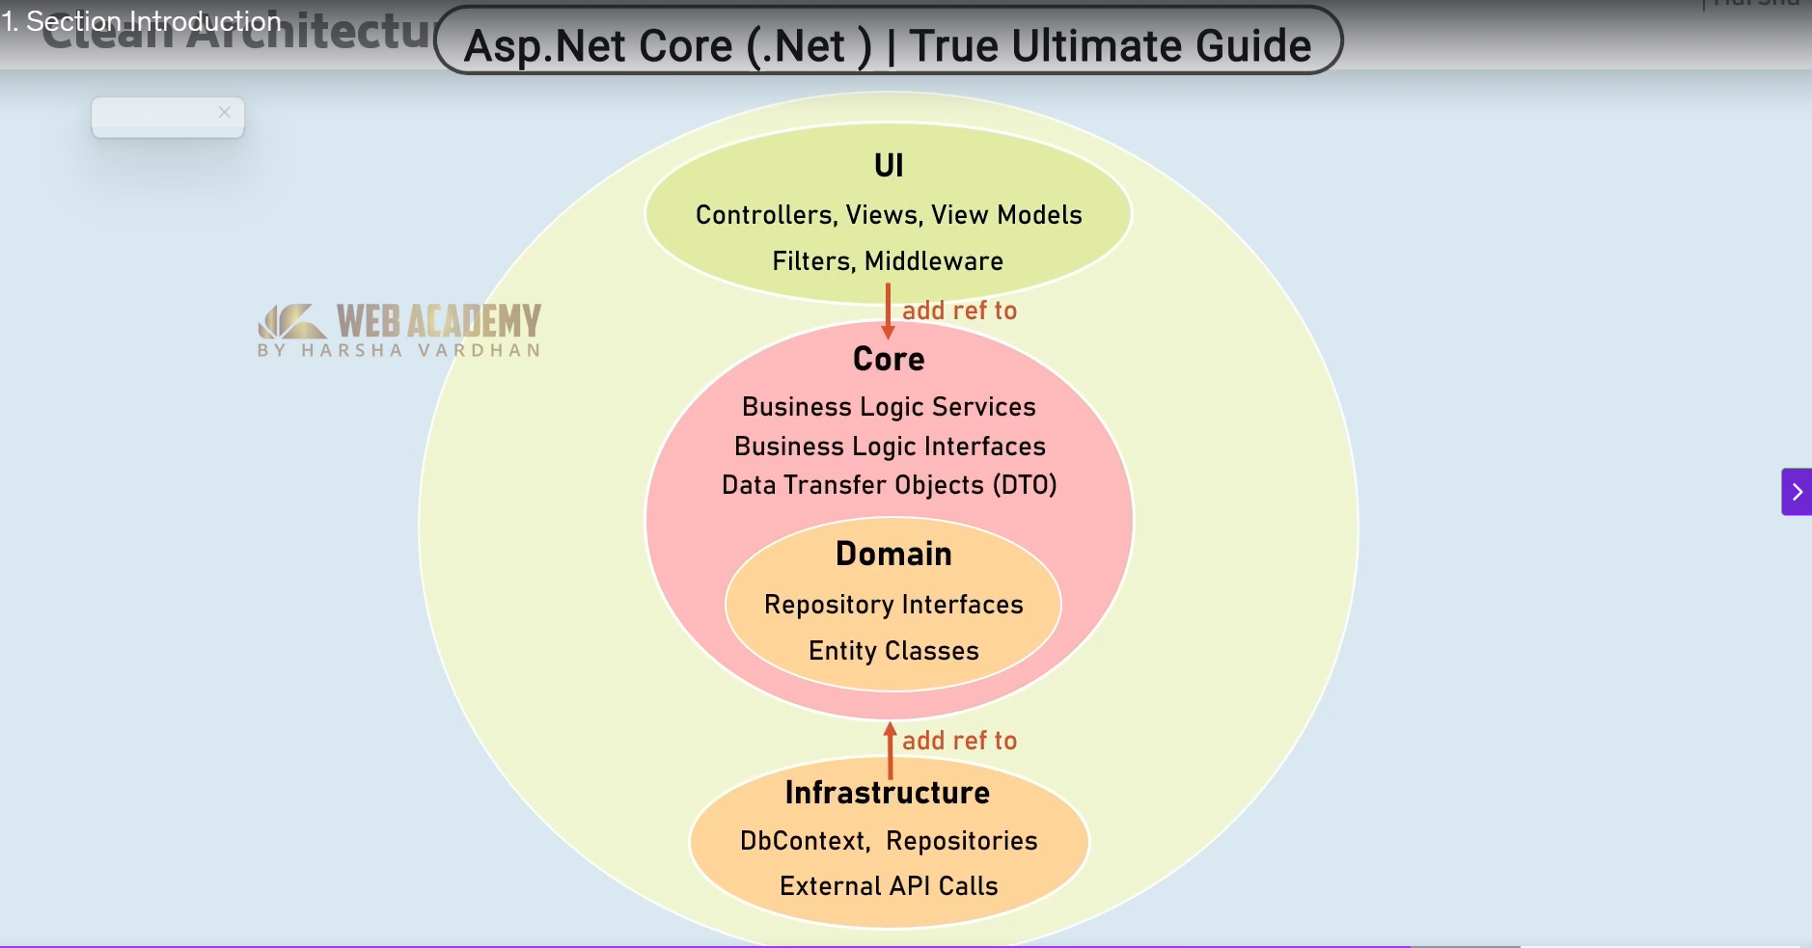

Dapper in .Net: ORM library in .net
Dapper v/s Entity Framework:
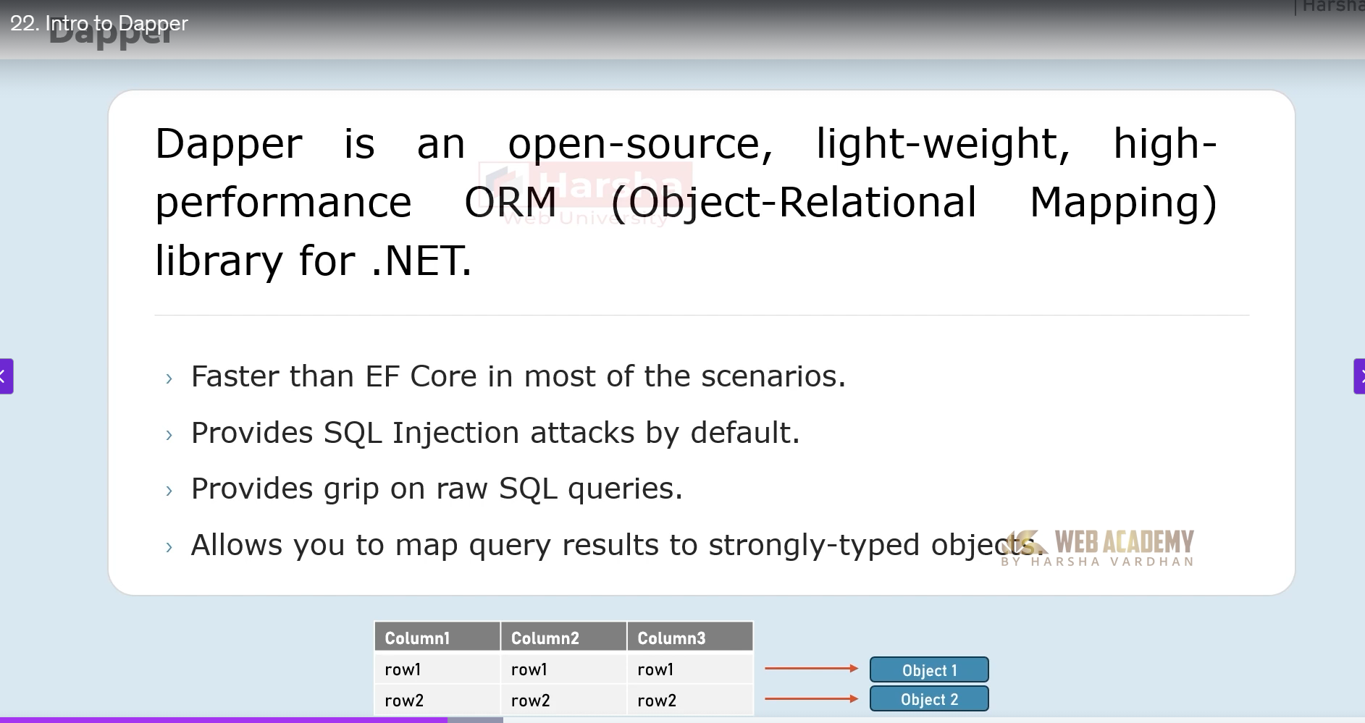
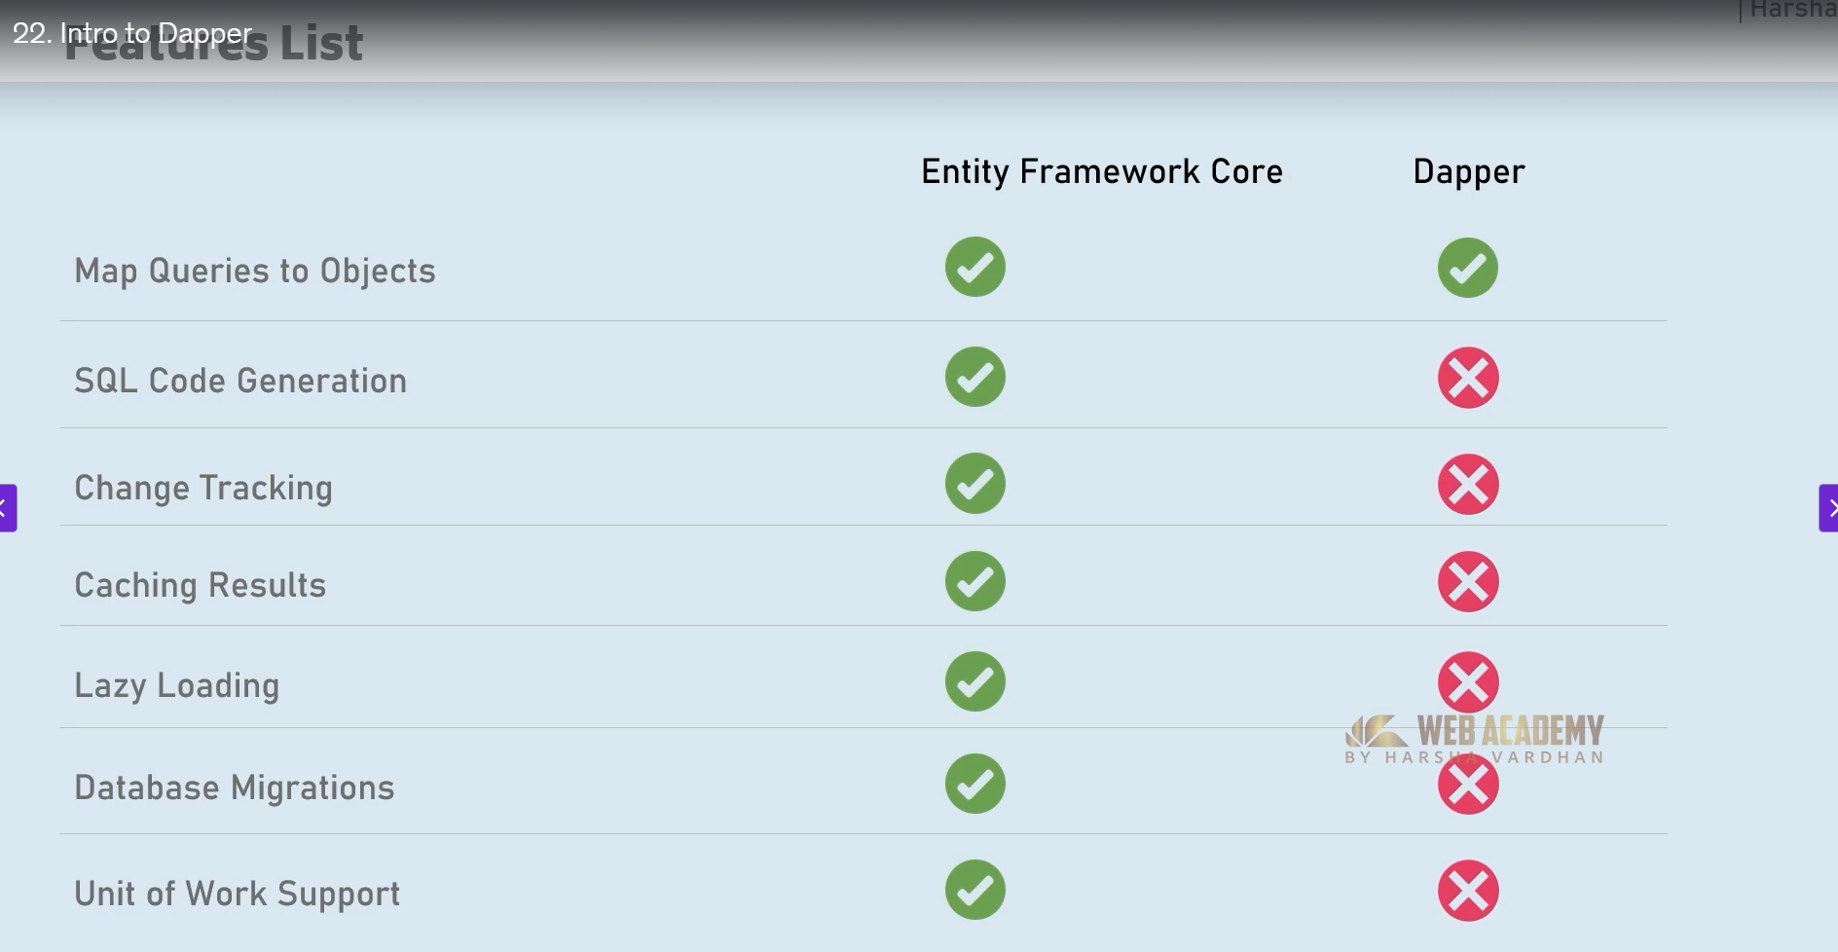
How to connect:
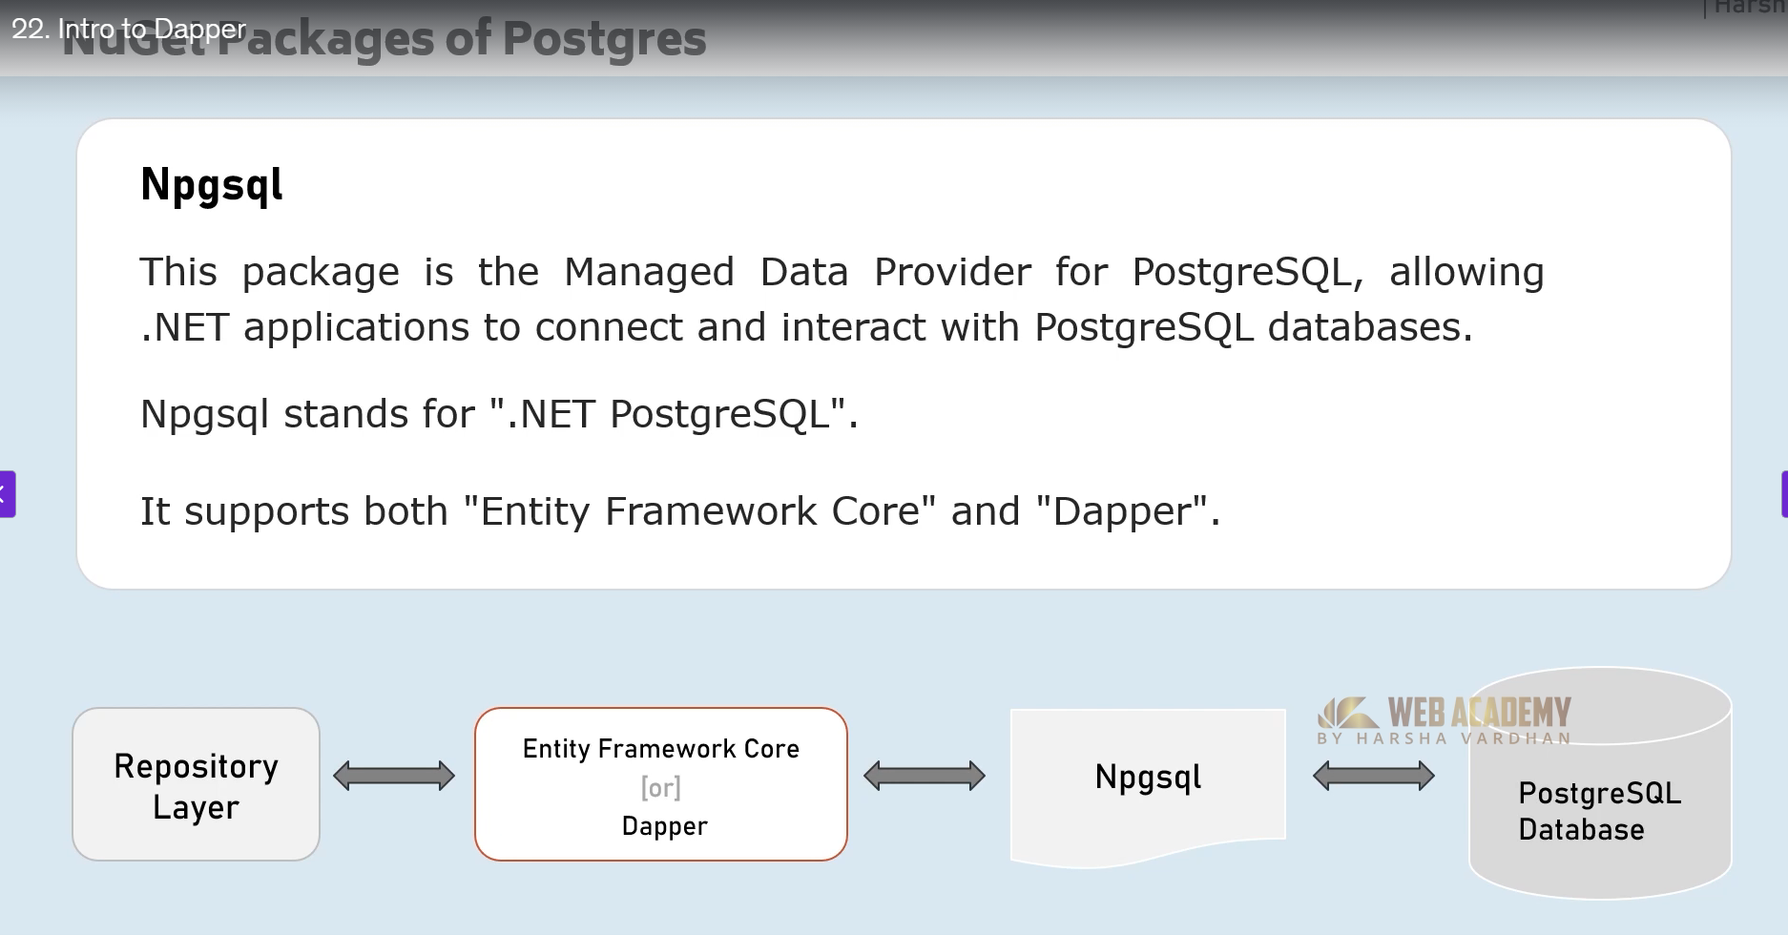
Methods in Dapper:
